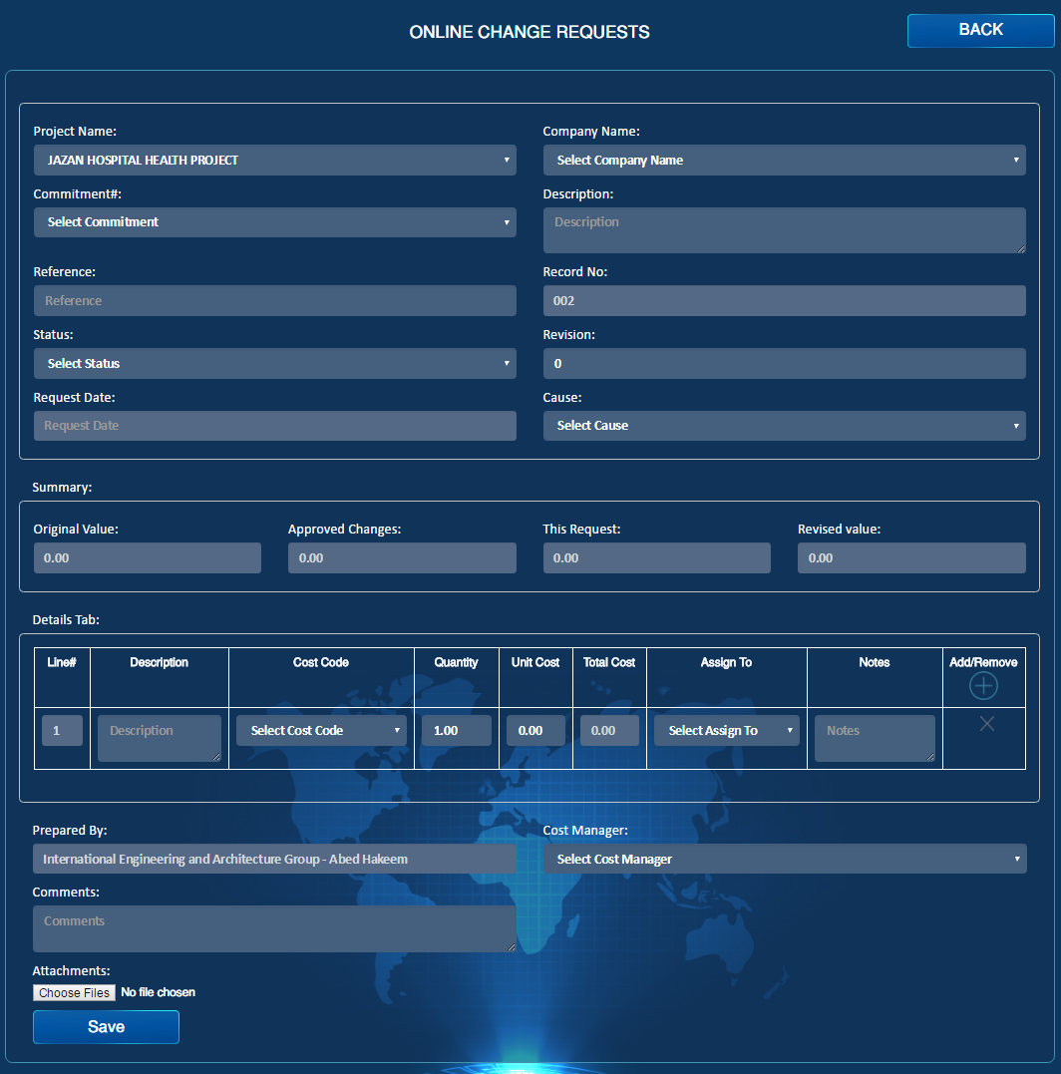

Import

Import

Export

Import

Approve

Import

Transmittal Letter

Import

Reject

Import

Draft

Import

Category

Import

Contract #

Email

Import

PDF

Import

Submit

Import

1. Cause should include: new scope, design changes.
2. Category field to be added and it should include: Cost, Time and Cost & Time.
3. Transmittal Letter, PDF & Email should be there.
4. All the 4 statuses will be in respond page.